
Fuhua-Parallel Set 2 · Sec 3 G3 EOY 2026 Paper 1 — Marking Scheme
Worked Solutions + Marking Scheme
Cambridge Learning Group · Fuhua-parallel practice paper, Set 2 · Paper 1 · 2026
14 pages · 80 marks

How to read this booklet:
BLACK — the question, written ON the original question paper
BLUE — the full step-by-step working and the reason for each line
RED — the marking scheme: where each B1 / M1 / A1 is earned, the traps,
and the key concept the question is testing

Mark codes: B1 independent answer mark · M1 method mark (earned even if
the answer is wrong) · A1 accuracy mark (only if the method mark was earned).

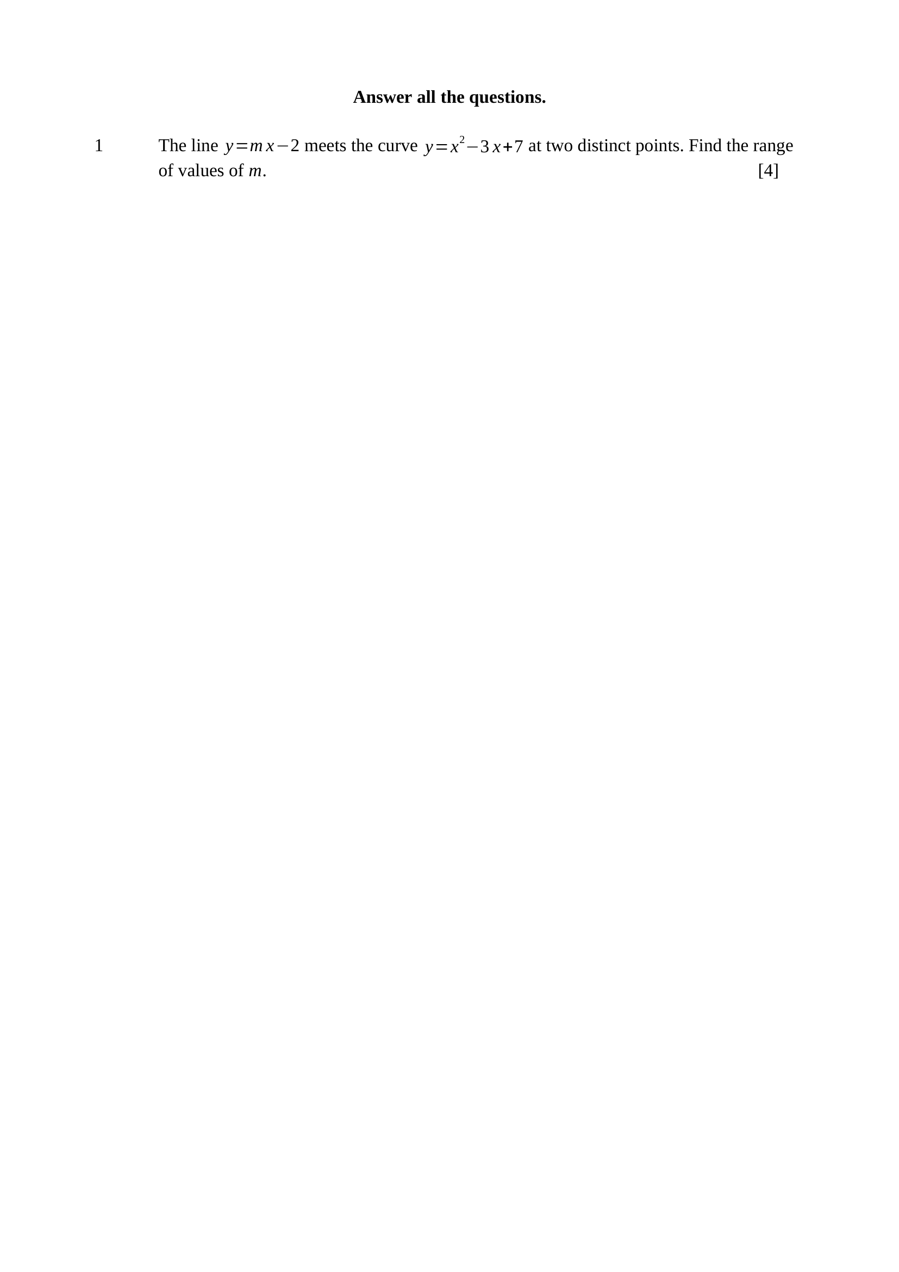
At the points of intersection:
$x^{2}−3x+7=mx−2$
$x^{2}−(3+m)x+9=0$
Two distinct points, so the discriminant is positive:
$(3+m)^{2}−4(1)(9)>0$
$\left(m+3)^{2}>36\right.$
$m+3>6$ or $m+3<−6$
$∴m>3$ or $m<−9$
Key concept: TWO DISTINCT points means $b^{2}−4ac>0$ — not $≥0$, and not $b^{2}−4ac=0$.
M1 – equates the two expressions and collects to $x^{2}−(3+m)x+9=0$
M1 – applies $b^{2}−4ac>0$ with $a=1, b=−(3+m), c=9$
M1 – solves the quadratic inequality in $m$
A1 – $m>3$ or $m<−9$
Trap – writing $−9<m<3$ reverses the inequality — the parabola in $m$ opens upwards, so the solution is the OUTSIDE pair of intervals.
Note – $c=9$, not $−9$: the $−2$ moves across as $+2$ onto the $+7$.

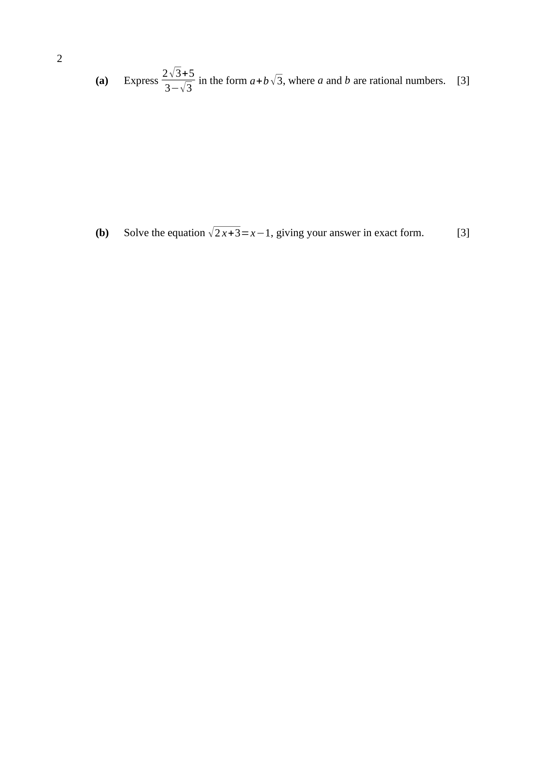
$\frac{2\sqrt{3}+5}{3−\sqrt{3}}×\frac{3+\sqrt{3}}{3+\sqrt{3}}$
numerator $N=\left(2\sqrt{3} + 5\right)\left(3 + \sqrt{3}\right)$
$N=6\sqrt{3}+2(3)+15+5\sqrt{3}$
$N=21+11\sqrt{3}$
denominator: $9−3=6$
$∴\frac{21+11\sqrt{3}}{6}=\frac{7}{2}+\frac{11}{6}\sqrt{3}$
Key concept: the conjugate of $3−\sqrt{3}$ is $3+\sqrt{3}$ — change the sign of the SURD term only.
M1 – multiplies by the conjugate $\frac{3+\sqrt{3}}{3+\sqrt{3}}$
M1 – expands the numerator, using $\sqrt{3}×\sqrt{3}=3$
A1 – $a=\frac{7}{2}, b=\frac{11}{6}$
Note – the question says RATIONAL, not integer — a fractional answer is expected here and must not be rounded.
$\sqrt{2x+3}=x−1$
squaring both sides: $2x+3=x^{2}−2x+1$
$x^{2}−4x−2=0$
$x=\frac{4±\sqrt{16+8}}{2}=2±\sqrt{6}$
check: $x−1≥0$, so $x≥1$
$2−\sqrt{6}≈−0.449$, which is rejected
$∴x=2+\sqrt{6}$
Key concept: squaring can create a root that does not satisfy the original equation — every answer must be checked.
M1 – squares correctly to $2x+3=x^{2}−2x+1$
M1 – formula or completing the square on $x^{2}−4x−2=0$
A1 – $x=2±\sqrt{6}$
A1 – rejects $2−\sqrt{6}$ with a reason, giving $x=2+\sqrt{6}$
Trap – the right-hand side is $x−1$, so the condition is $x≥1$ — checking only $2x+3≥0$ keeps the wrong root.

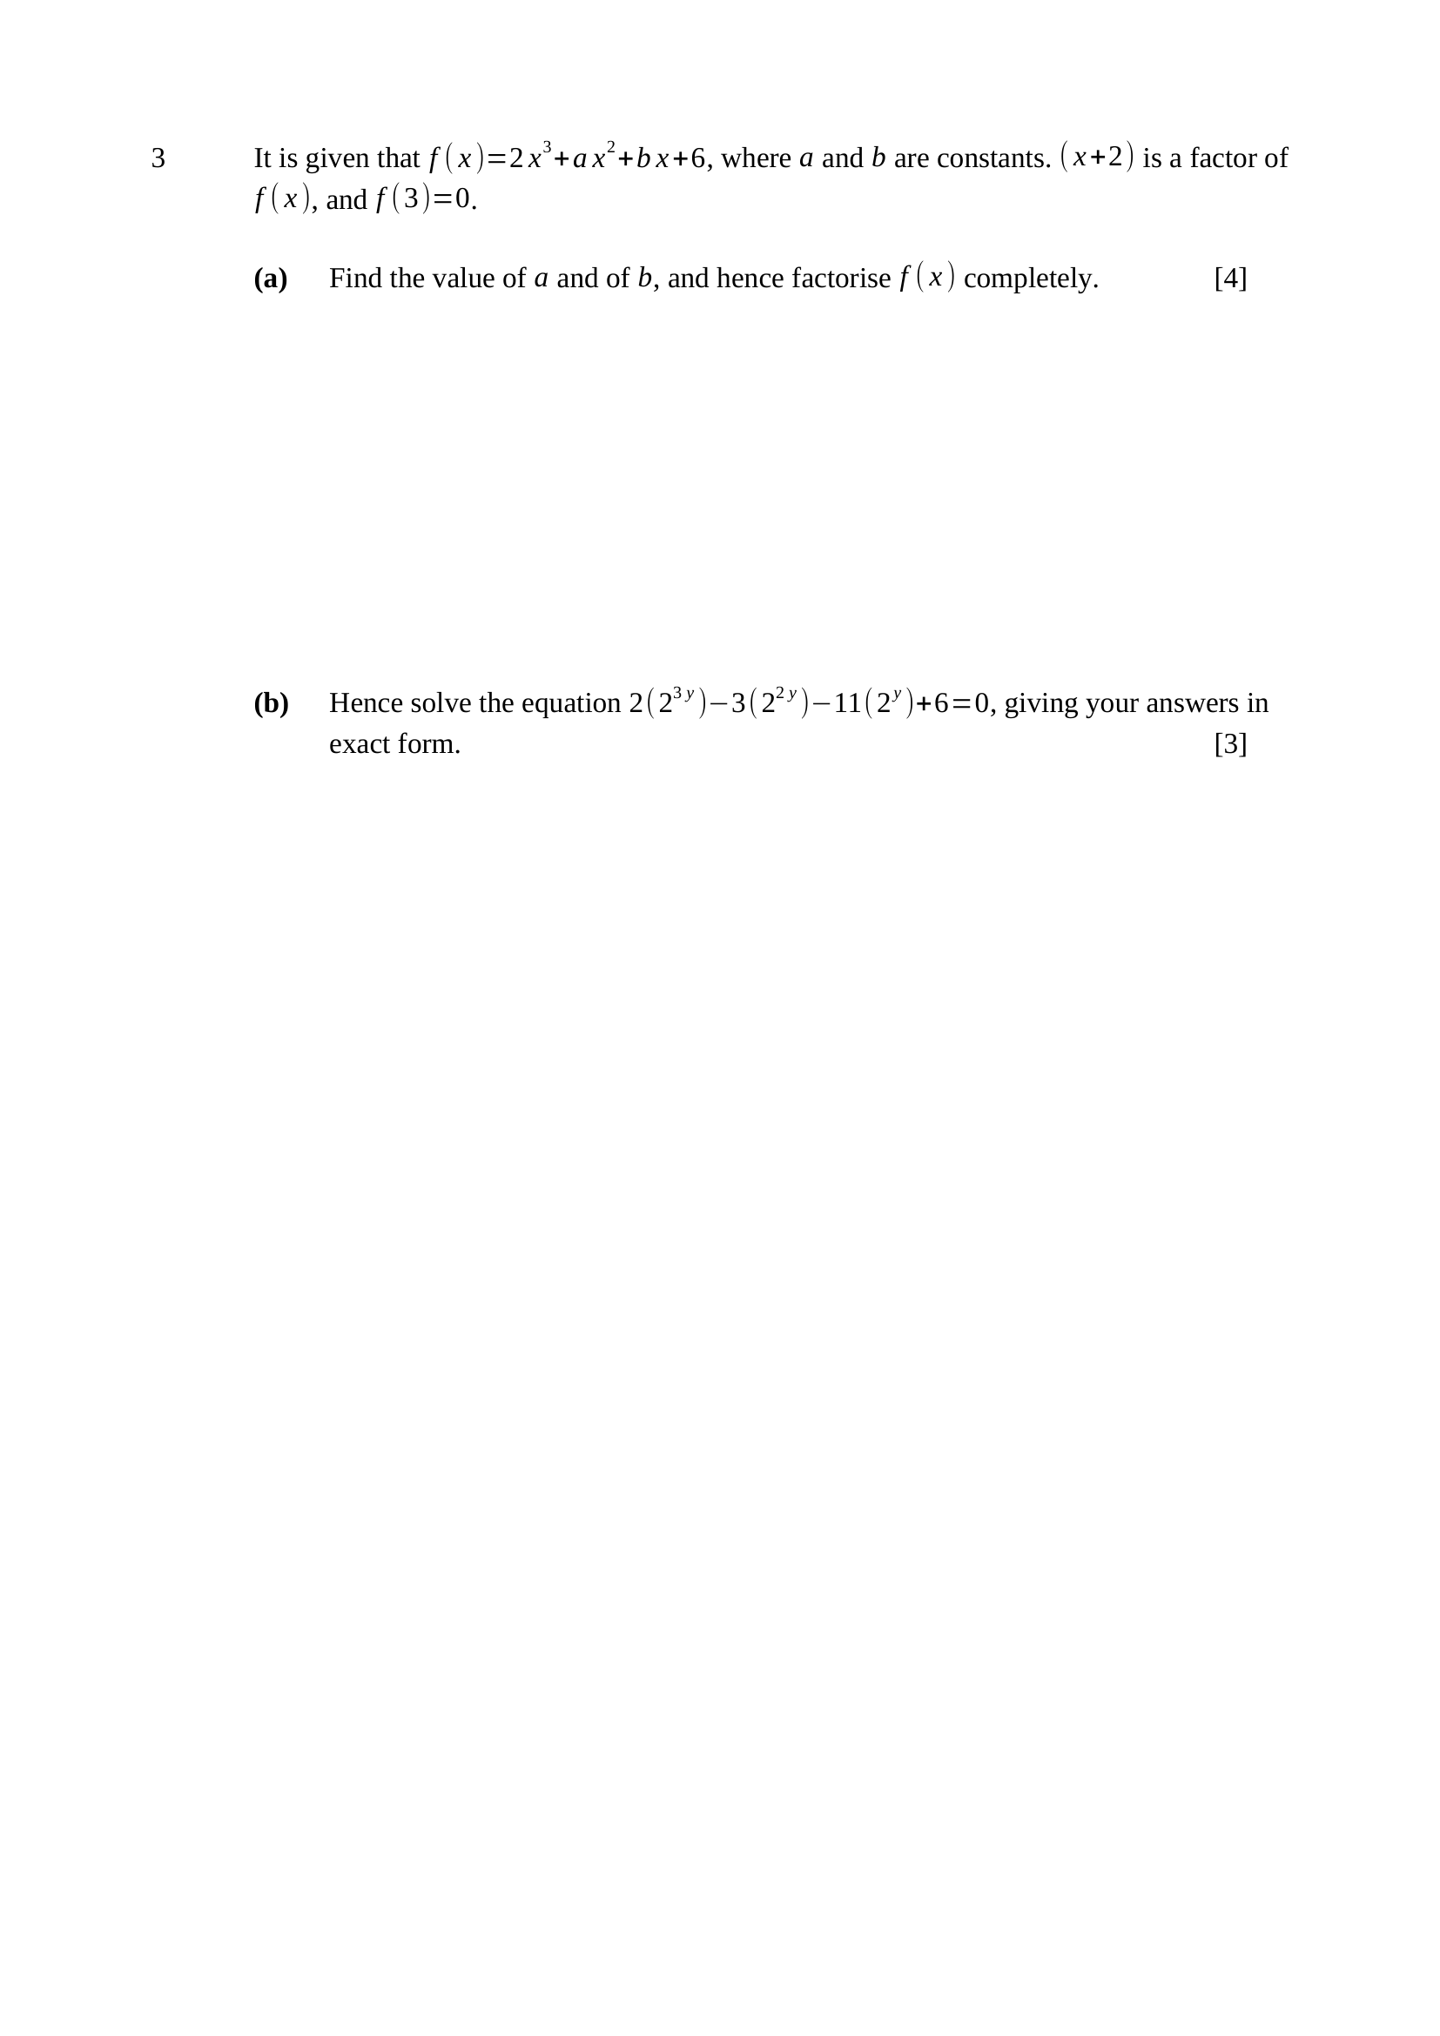
$f(−2)=0$: $−16+4a−2b+6=0$
$2a−b=5$ ... (1)
$f(3)=0$: $54+9a+3b+6=0$
$3a+b=−20$ ... (2)
$\left(1)+(2\right)$: $5a=−15$, so $a=−3$
from (1): $b=2(−3)−5=−11$
$f(x)=2x^{3}−3x^{2}−11x+6$
$f(x)=(x+2)\left(2x^{2}−7x+3\right)$
$∴f(x)=(x+2)(2x−1)(x−3)$
Key concept: two conditions of DIFFERENT kinds — a factor and a stated value — but both give a linear equation in $a$ and $b$.
M1 – uses $f(−2)=0$ correctly
M1 – uses $f(3)=0$ and solves the pair simultaneously
A1 – $a=−3, b=−11$
A1 – $\left(x+2)(2x−1)(x−3\right)$
Note – long division or comparing coefficients both earn the factorising mark.
let $u=2^{y}$, so $2^{3y}=u^{3}$ and $2^{2y}=u^{2}$
$2u^{3}−3u^{2}−11u+6=0$, which is $f(u)=0$
$(u+2)(2u−1)(u−3)=0$
$u=−2$ (rejected: $2^{y}>0$), $u=\frac{1}{2}$, $u=3$
$2^{y}=\frac{1}{2}=2^{−1}$, so $y=−1$
$2^{y}=3$, so $y=\log_{2}3$
$∴y=−1$ or $y=\log_{2}3$
Key concept: the SAME cubic, with $2^{y}$ in place of $x$ — spot the substitution rather than starting again.
M1 – substitutes $u=2^{y}$ and recognises $f(u)=0$
A1 – rejects $u=−2$, stating that a power of $2$ is always positive
A1 – $y=−1$ and $y=\log_{2}3$
Trap – giving $y=\log_{2}(−2)$ as a third answer — it does not exist.
Note – exact form is demanded, so $\log_{2}3$ must not be written as $1.58$.

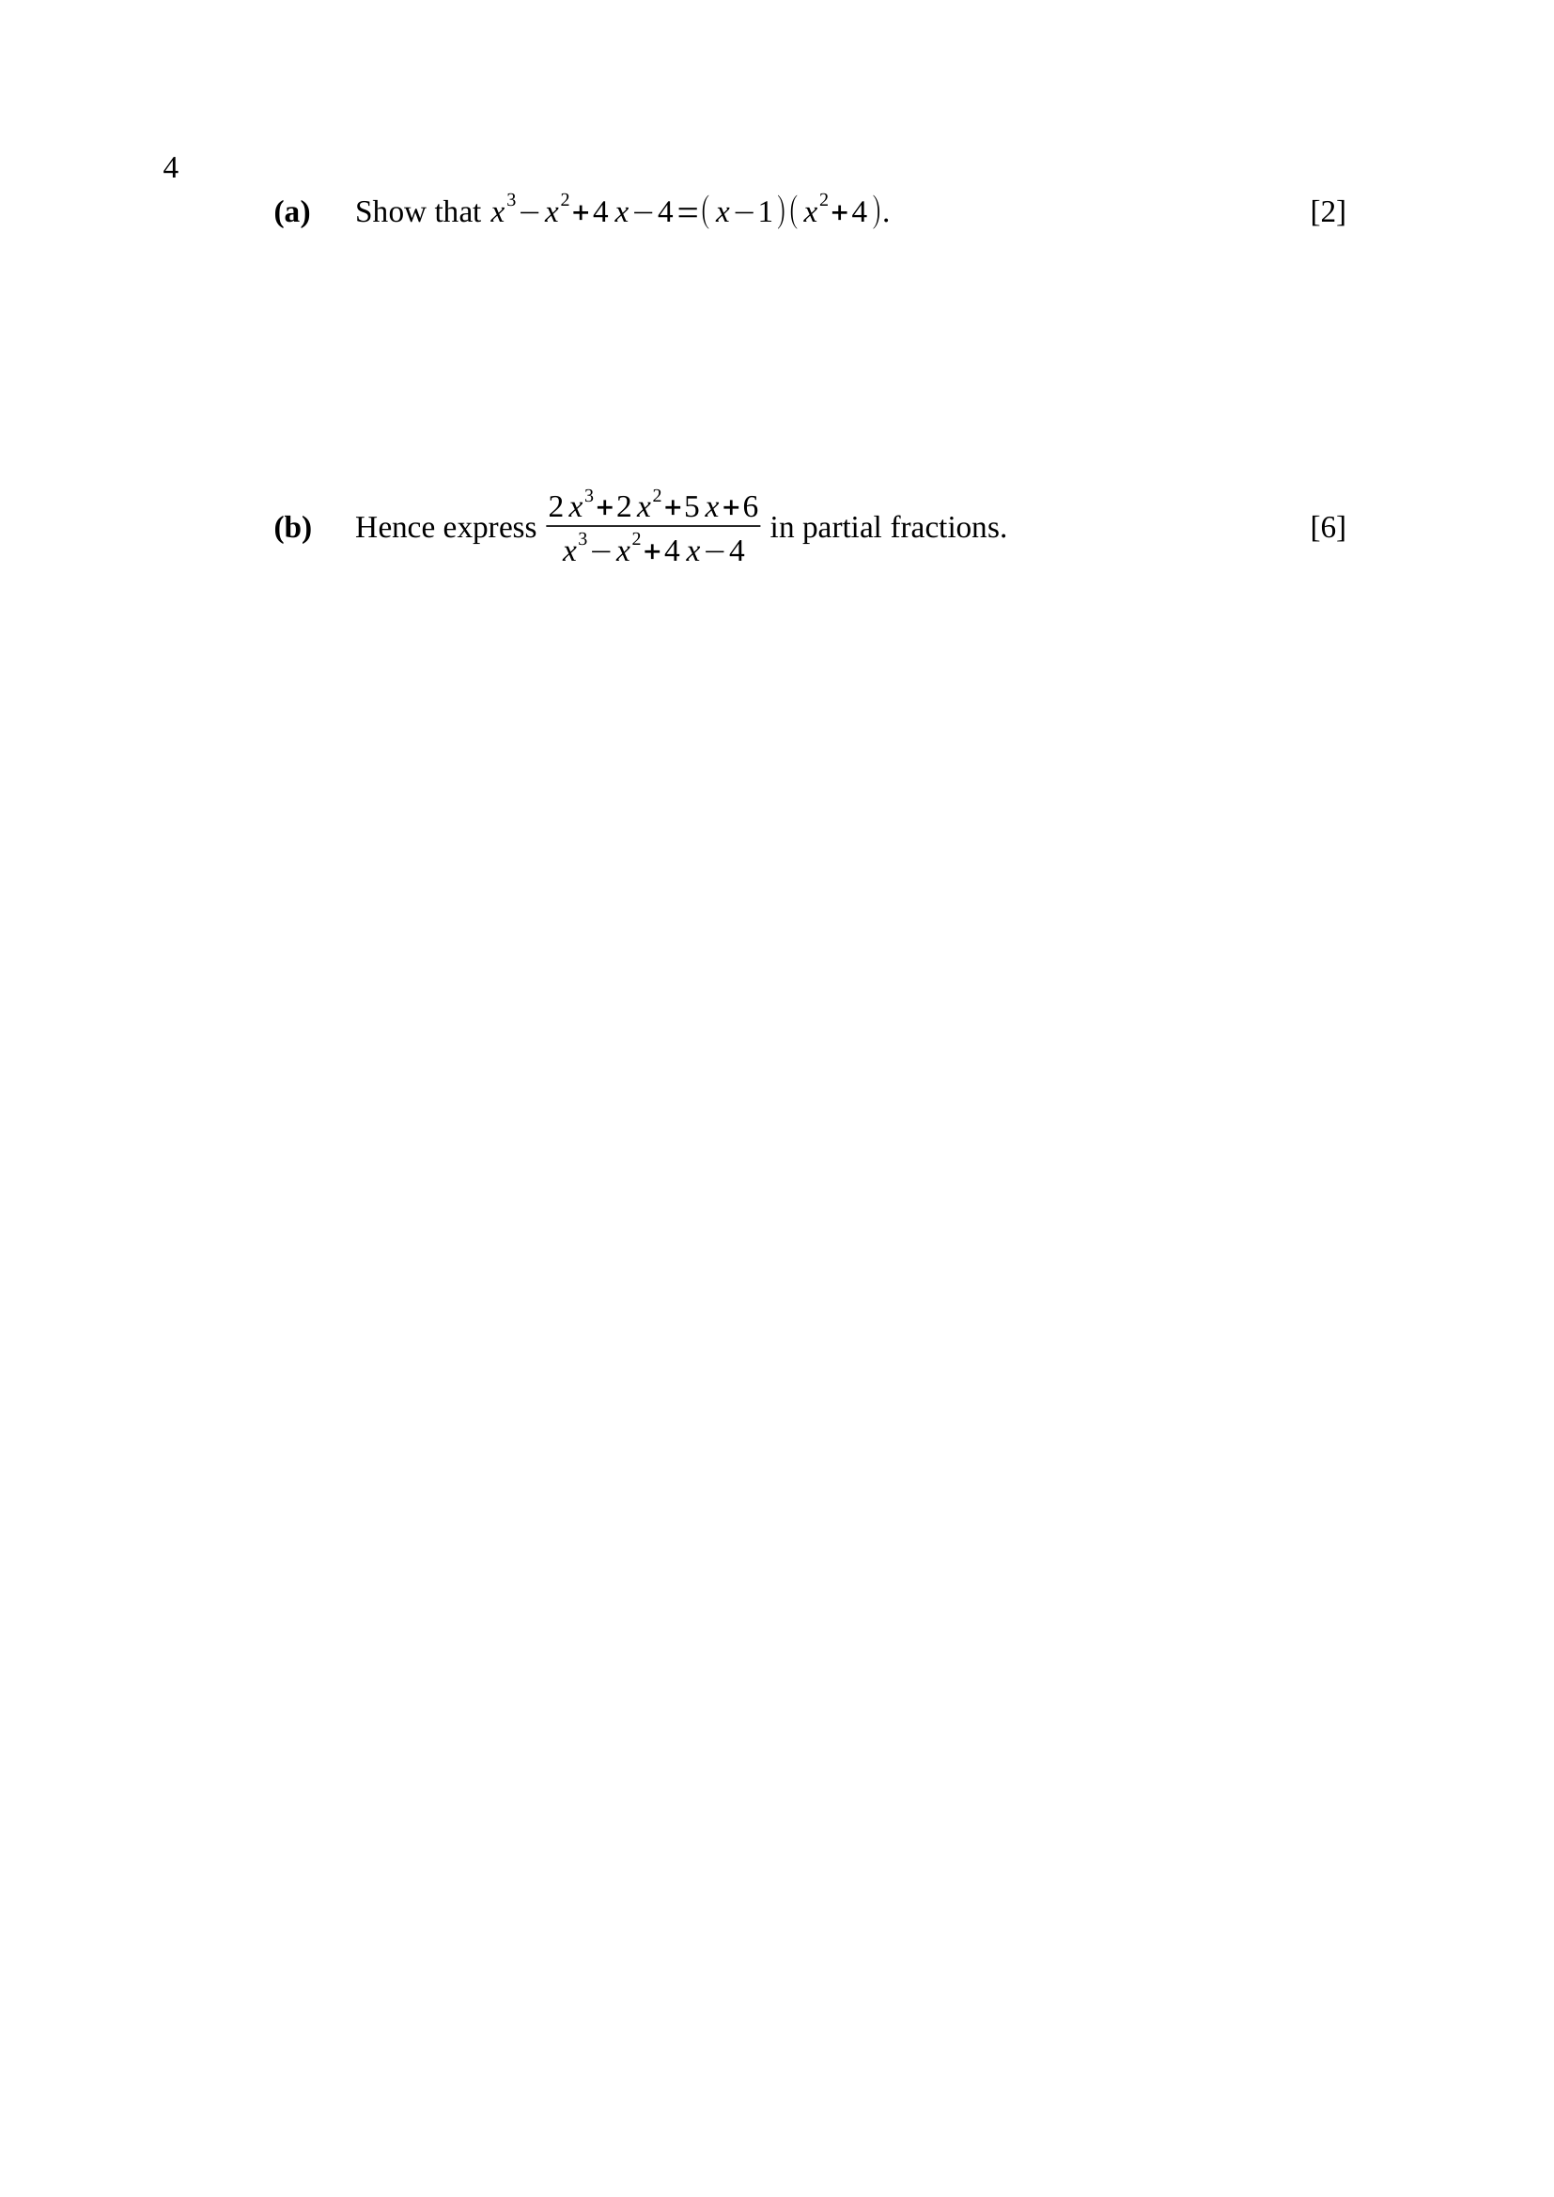
let $g(x)=x^{3}−x^{2}+4x−4$ and group in pairs:
$g(x)=x^{2}(x−1)+4(x−1)$
$g(x)=(x−1)\left(x^{2} + 4\right)$ (shown)
Key concept: factorising by grouping — the common bracket $\left(x − 1\right)$ appears twice.
M1 – groups as $x^{2}(x−1)+4(x−1)$
A1 – reaches $(x−1)\left(x^{2} + 4\right)$ with the working shown
Note – $x^{2}+4$ has no real factors, so it stays whole — this is the irreducible quadratic used in part (b).
degree $3$ over degree $3$, so the fraction is improper:
$\frac{2x^{3}+2x^{2}+5x+6}{x^{3}−x^{2}+4x−4}=2+\frac{R(x)}{(x−1)\left(x^{2} + 4\right)}$
$R(x)=\left(2x^{3} + 2x^{2} + 5x + 6\right)$
$−2\left(x^{3}−x^{2}+4x−4\right)$
$R(x)=4x^{2}−3x+14$
$\frac{4x^{2}−3x+14}{(x−1)\left(x^{2} + 4\right)}≡\frac{A}{x−1}+\frac{Bx+C}{x^{2}+4}$
$4x^{2}−3x+14≡A\left(x^{2} + 4\right)+(Bx+C)(x−1)$
$x=1$: $15=5A$, so $A=3$
compare $x^{2}$: $4=A+B$, so $B=1$
compare constants: $14=4A−C$, so $C=−2$
$∴2+\frac{3}{x−1}+\frac{x−2}{x^{2}+4}$
Key concept: divide FIRST — an improper fraction has a quotient before any partial fraction is written.
M1 – identifies the fraction as improper and extracts the quotient $2$
A1 – remainder $4x^{2}−3x+14$
M1 – correct form $\frac{A}{x−1}+\frac{Bx+C}{x^{2}+4}$
M1 – substitution or comparison to find the constants
A1 – $A=3, B=1, C=−2$
A1 – $2+\frac{3}{x−1}+\frac{x−2}{x^{2}+4}$
Trap – writing $\frac{B}{x^{2}+4}$ instead of $\frac{Bx+C}{x^{2}+4}$ loses the form mark and makes the system inconsistent.

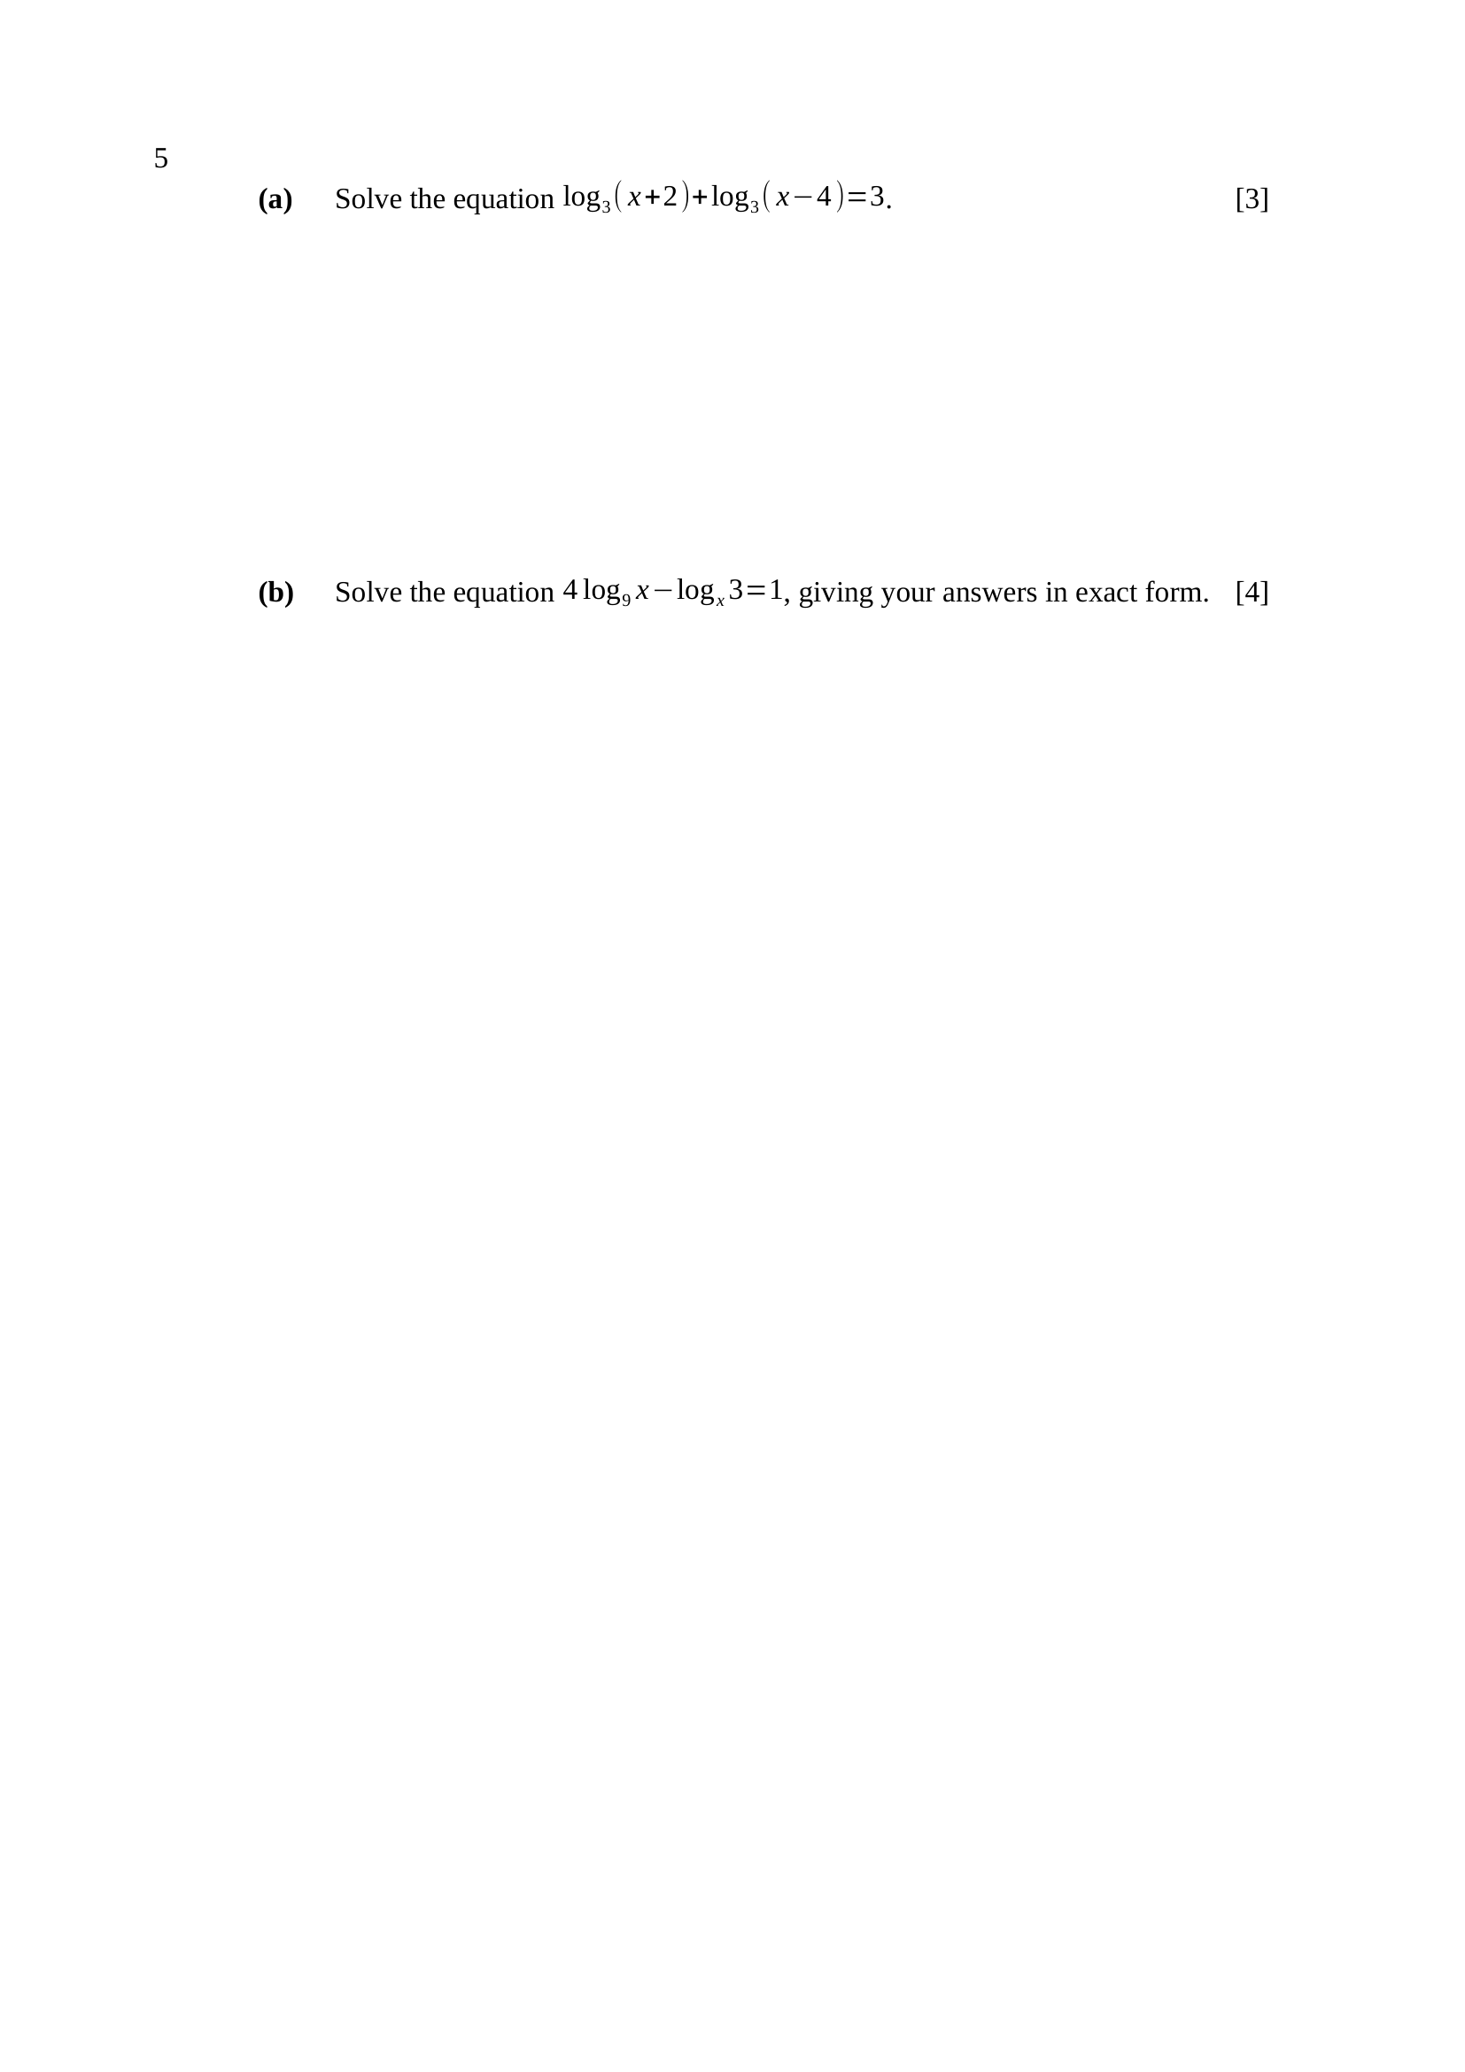
$\log_{3}(x+2)+\log_{3}(x−4)=3$
$\log_{3}\left[(x+2)(x−4)\right]=3$
$(x+2)(x−4)=3^{3}=27$
$x^{2}−2x−8=27$
$x^{2}−2x−35=0$
$(x−7)(x+5)=0$
$x=7$ or $x=−5$
$x=−5$ makes $\log_{3}(x−4)$ undefined, so it is rejected
$∴x=7$
Key concept: the product law first, then undo the logarithm with the base as a power.
M1 – combines to a single logarithm
M1 – writes $(x+2)(x−4)=3^{3}$
A1 – $x^{2}−2x−35=0$
A1 – $x=7$ only, with $x=−5$ rejected and a reason given
Trap – keeping $x=−5$: both brackets must be POSITIVE, so the domain is $x>4$.
let $t=\log_{3}x$
$\log_{9}x=\frac{\log_{3}x}{\log_{3}9}=\frac{t}{2}$
$\log_{x}3=\frac{1}{\log_{3}x}=\frac{1}{t}$
$4\left(\frac{t}{2}\right)−\frac{1}{t}=1$
$2t−\frac{1}{t}=1$
$2t^{2}−t−1=0$
$(2t+1)(t−1)=0$
$t=1$ or $t=−\frac{1}{2}$
$∴x=3$ or $x=3^{−\frac{1}{2}}=\frac{\sqrt{3}}{3}$
Key concept: change EVERYTHING to base $3$ — two different bases cannot be combined until they match.
M1 – $\log_{9}x=\frac{1}{2}\log_{3}x$
M1 – $\log_{x}3=\frac{1}{\log_{3}x}$ (the reciprocal law)
M1 – forms and solves $2t^{2}−t−1=0$
A1 – $x=3$ and $x=\frac{\sqrt{3}}{3}$
Note – both roots are valid: $x>0$ and $x≠1$ are the only restrictions.
Trap – discarding $t=−\frac{1}{2}$ as impossible — a logarithm may be negative; it is the ARGUMENT that cannot be.

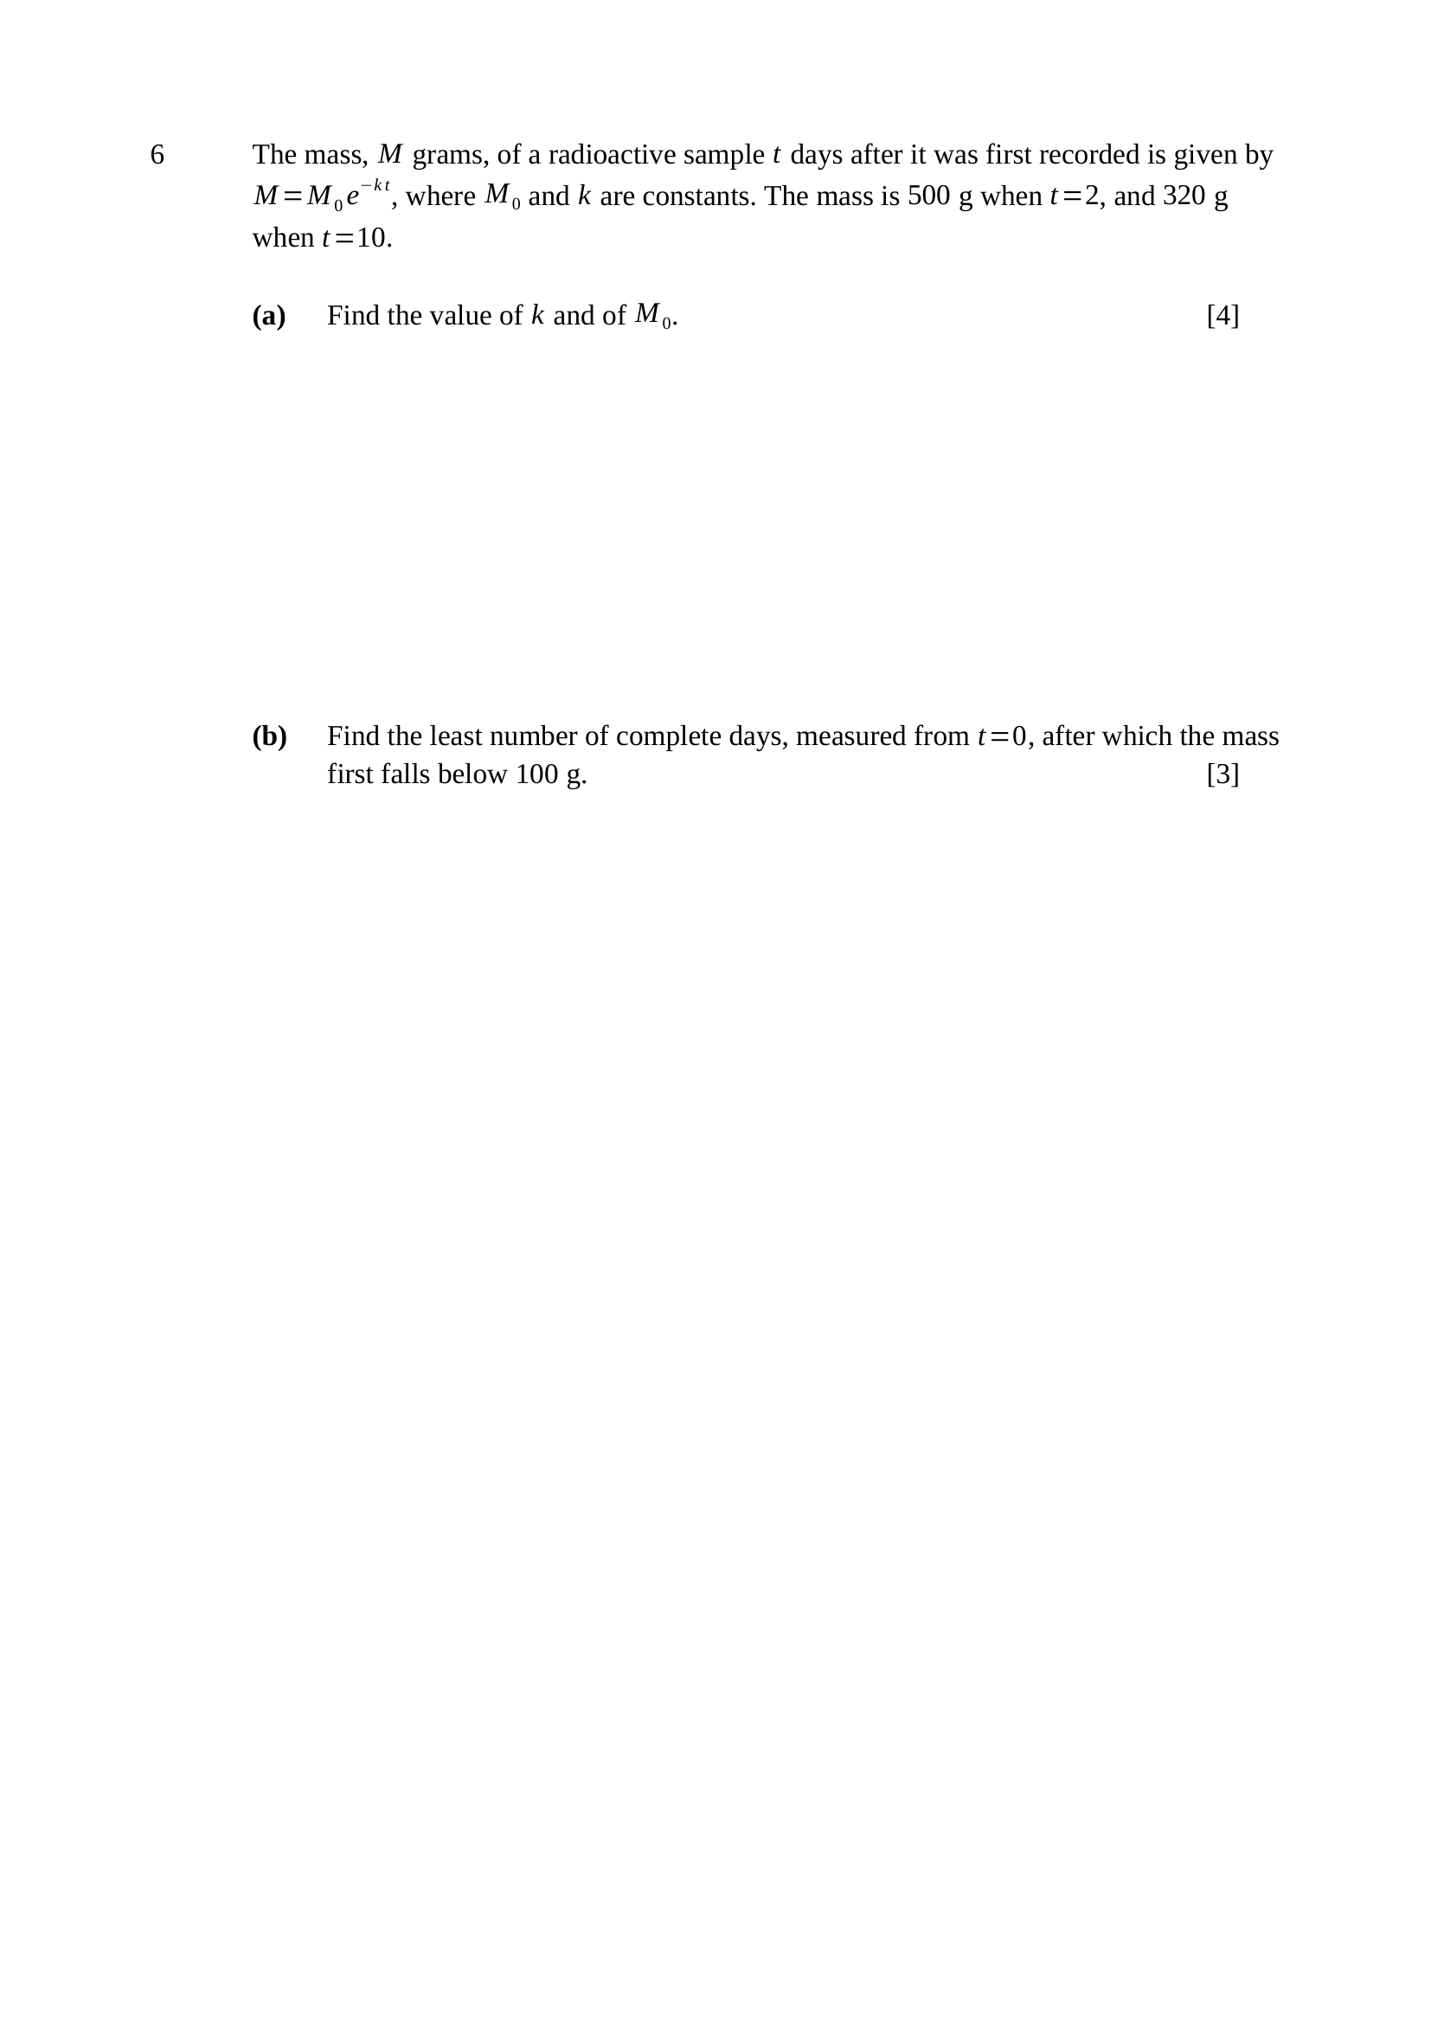
$500=M_{0}e^{−2k}$ ... (1)
$320=M_{0}e^{−10k}$ ... (2)
$\frac{\left(2\right)}{\left(1\right)}$: $\frac{320}{500}=e^{−8k}$
$e^{−8k}=0.64$
$−8k=ln0.64$
$k=0.055786…≈0.0558$
from (1): $M_{0}=500e^{2k}=500e^{0.111572}$
$∴M_{0}≈559$ g
Key concept: $M_{0}$ is unknown AND the readings are not at $t=0$ — divide the two equations to eliminate it.
M1 – two correct equations from the two readings
M1 – divides to eliminate $M_{0}$, reaching $e^{−8k}=0.64$
A1 – $k≈0.0558$
A1 – $M_{0}≈559$
Trap – assuming $M_{0}=500$ — that is the mass at $t=2$, not at $t=0$.
Note – keep the unrounded $k$ in the calculator for part (b).
$100=M_{0}e^{−kt}$
$e^{−kt}=\frac{100}{559.017}$
$−kt=ln\left(0.178884\right)$
$t=\frac{1.720898}{0.055786}=30.849…$
the mass is still above $100$ g at $t=30$
$∴$ least number of complete days: $t=31$
Key concept: a CEILING answer — the decimal is not the answer, the next whole day is.
M1 – sets $M=100$ and takes logarithms
A1 – $t=30.8$ (accept $30.8$ to $30.9$)
A1 – $31$ days
Trap – rounding $30.849$ to $31$ by ordinary rounding is luck, not method — state that the mass first drops below $100$ g DURING day $31$.
Note – using the rounded $k=0.0558$ gives $30.84$, still $31$ — but marks for accuracy follow through only if the method is shown.

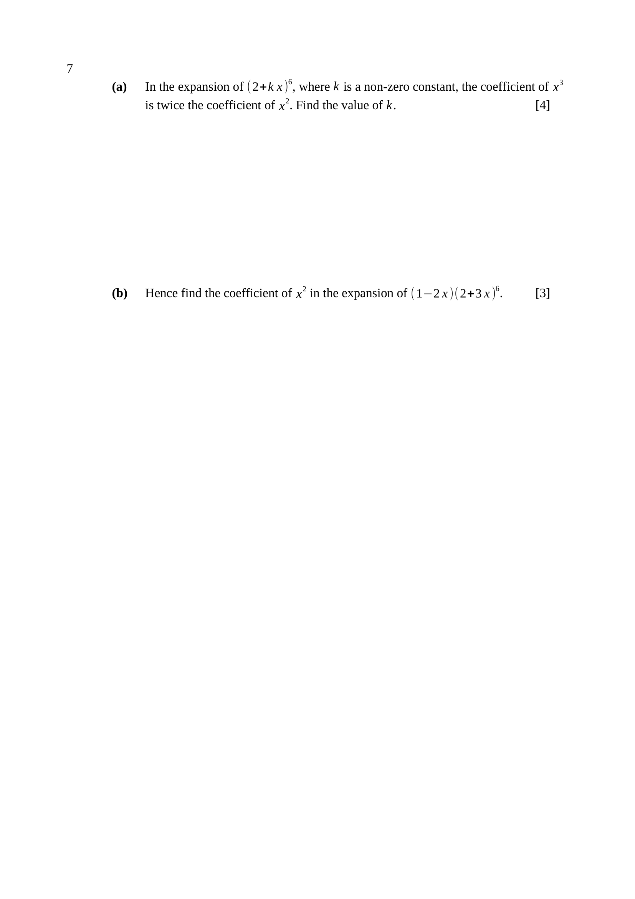
general term: ${\left({6 \atop r})2^{6−r}(kx\right)}^{r}$
coefficient of $x^{2}$: $({6 \atop 2})2^{4}k^{2}=15(16)k^{2}=240k^{2}$
coefficient of $x^{3}$: $({6 \atop 3})2^{3}k^{3}=20(8)k^{3}=160k^{3}$
$160k^{3}=2\left(240k^{2}\right)$
$k≠0$, so divide by $160k^{2}$: $∴k=3$
Key concept: form BOTH coefficients in terms of $k$, then let the stated relation give the equation.
M1 – correct general term with both the power of $2$ and the power of $k$
A1 – $240k^{2}$ and $160k^{3}$
M1 – forms $160k^{3}=2\left(240k^{2}\right)$ and divides by $k^{2}$
A1 – $k=3$
Trap – dropping the $2^{6−r}$ factor — the coefficients are then $15k^{2}$ and $20k^{3}$ and $k$ comes out as $\frac{3}{2}$.
from (a) the bracket is ${\left(2 + 3x\right)}^{6}$
coefficient of $x$: $({6 \atop 1})2^{5}(3)=6(32)(3)=576$
coefficient of $x^{2}$: $({6 \atop 2})2^{4}\left(3^{2}\right)=15(16)(9)=2160$
$\left(1 − 2x\right){\left(2 + 3x\right)}^{6}$ gives $x^{2}$ from:
$1×2160$ and $(−2x)×576x$
$1(2160)+(−2)(576)=2160−1152$
$∴$ coefficient of $x^{2}$ is $1008$
Key concept: TWO terms contribute — the $x^{2}$ term times $1$, and the $x$ term times $−2x$.
M1 – both coefficients $576$ and $2160$ from the expansion
M1 – combines $1×2160$ with $(−2)×576$
A1 – $1008$
Trap – quoting $2160$ alone ignores the bracket in front — one slip in (a) carries through both marks here.

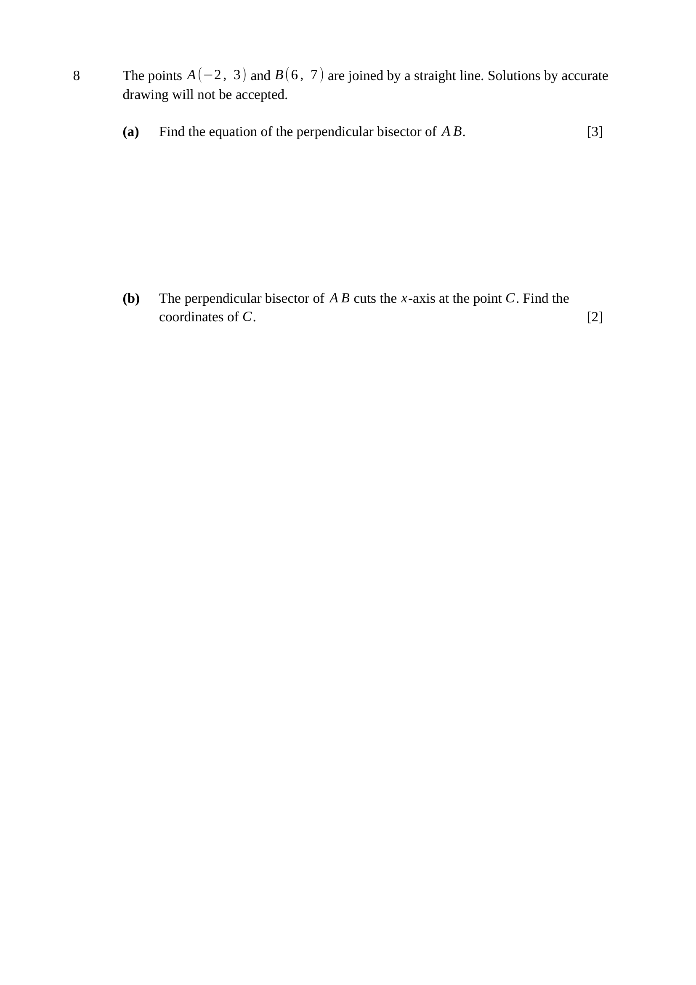
midpoint of $AB$: $\left(\frac{−2+6}{2} , \frac{3+7}{2}\right)=(2, 5)$
gradient of $AB$: $\frac{7−3}{6−(−2)}=\frac{4}{8}=\frac{1}{2}$
perpendicular gradient: $−2$
$y−5=−2(x−2)$
$∴y=−2x+9$
Key concept: a perpendicular bisector needs BOTH the midpoint and the negative reciprocal gradient.
B1 – midpoint $\left(2 , 5\right)$
M1 – gradient $\frac{1}{2}$, then perpendicular gradient $−2$
A1 – $y=−2x+9$
Note – $m_{1}m_{2}=−1$ is the test; $\frac{1}{2}×(−2)=−1$ ✓
on the $x$-axis, $y=0$:
$0=−2x+9$
$x=\frac{9}{2}$
$∴C\left(\frac{9}{2} , 0\right)$
Key concept: the $x$-axis is the line $y=0$.
M1 – substitutes $y=0$ into the bisector
A1 – $C\left(\frac{9}{2} , 0\right)$
Note – leave it as $\frac{9}{2}$ — $4.5$ is accepted, $4$ is not.

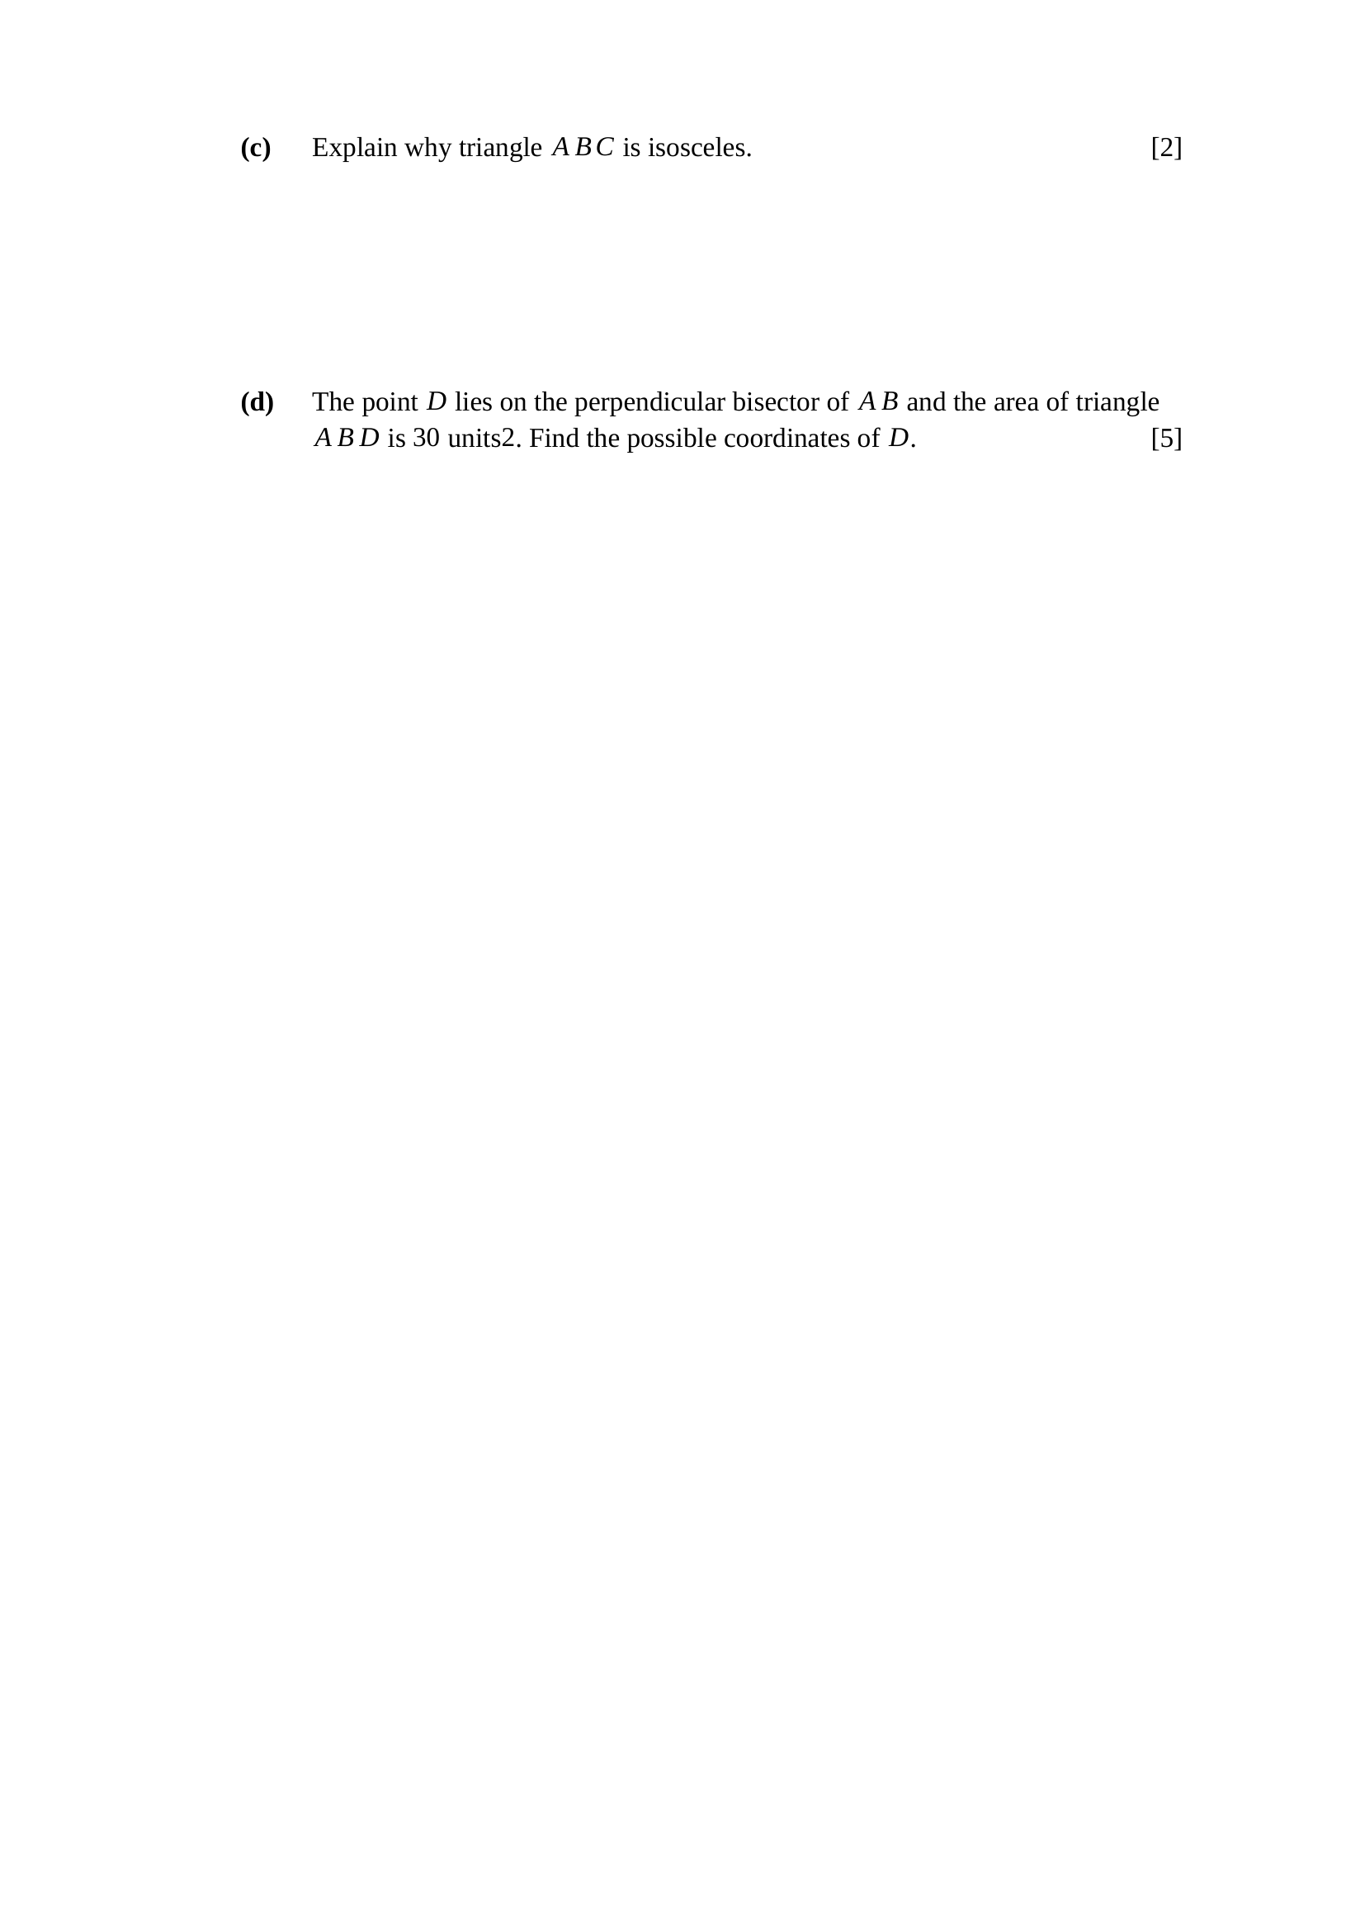
$C$ lies on the perpendicular bisector of $AB$.
Every point on the perpendicular bisector of $AB$ is equidistant from $A$ and $B$.
$∴CA=CB$, so triangle $ABC$ is isosceles.
Key concept: this is the REASONING mark — quote the equidistance property, do not merely compute.
B1 – states that $C$ lies on the perpendicular bisector of $AB$
B1 – concludes $CA=CB$, hence isosceles
Note – a full distance calculation showing $CA=CB$ scores both marks, but the one-line property argument is what the examiner wants.
$AB=\sqrt{8^{2}+4^{2}}=\sqrt{80}=4\sqrt{5}$
$\text{area}=\frac{1}{2}×AB×h=30$
$h=\frac{60}{4\sqrt{5}}=\frac{15}{\sqrt{5}}=3\sqrt{5}$
$D$ is on the bisector, so $h$ is measured from the midpoint $M(2, 5)$
along the bisector, whose direction is $\frac{\left(1, −2\right)}{\sqrt{5}}$
$D=(2, 5)±3\sqrt{5}×\frac{\left(1, −2\right)}{\sqrt{5}}=(2, 5)±3(1, −2)$
$∴D(5, −1)$ or $D(−1, 11)$
Key concept: the perpendicular bisector is already perpendicular to $AB$, so the distance from $D$ to $AB$ is just $MD$.
M1 – $AB=4\sqrt{5}$
M1 – uses $\text{area}=\frac{1}{2}×AB×h$ to get $h=3\sqrt{5}$
M1 – measures $3\sqrt{5}$ from $M(2, 5)$ along the bisector
A1 – $D(5, −1)$
A1 – $D(−1, 11)$
Trap – giving only one point — POSSIBLE coordinates means both sides of $AB$ must be given.
Note – the shoelace formula with $D(x, −2x+9)$ also works and earns the same marks.


$y=ax^{b}$
$lgy=lga+blgx$
plot $lgy$ against $lgx$: gradient $b$, vertical intercept $lga$.
$lgx$: $0, 0.602, 1.204, 1.556, 2.000$
$lgy$: $0.477, 0.778, 1.079, 1.255, 1.477$
Key concept: take logarithms of BOTH variables — a power law needs $lgx$, not $x$.
B1 – $lgy=lga+blgx$
B1 – states: plot $lgy$ against $lgx$, gradient $b$, intercept $lga$
B1 – both logarithm rows computed and a ruled straight line drawn
Trap – plotting $lgy$ against $x$ suits $y=ab^{x}$, not $y=ax^{b}$.

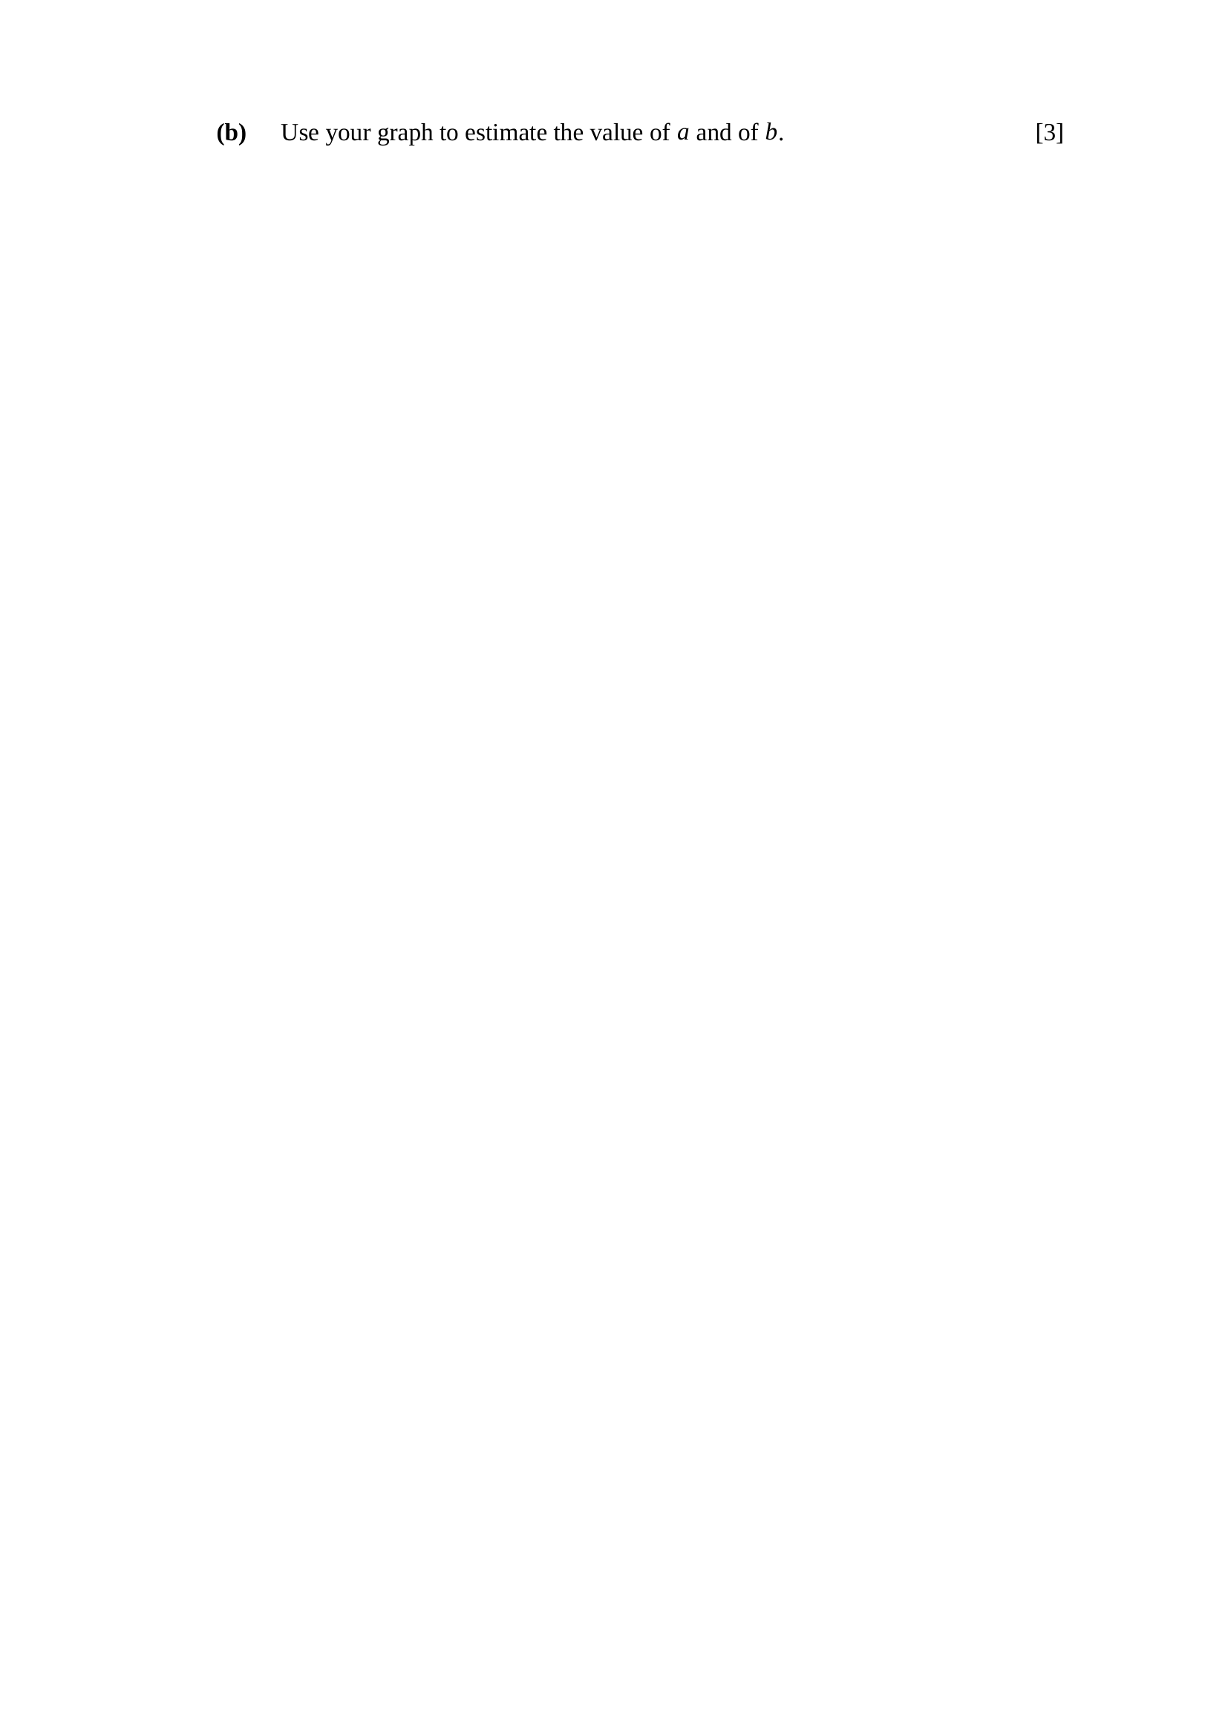
gradient $b=\frac{1.477−0.477}{2.000−0}=\frac{1.000}{2.000}$
$b≈0.5$
$\text{vertical intercept}=lga=0.477$
$a={10}^{0.477}$
$∴a≈3, b≈0.5$
Key concept: the intercept is $lga$, NOT $a$ — one more step is needed.
M1 – gradient from two points on the drawn line
A1 – $b≈0.5$
M1 – reads the intercept and applies $a={10}^{\text{intercept}}$
A1 – $a≈3$
Note – accept $a$ from $2.8$ to $3.2$ and $b$ from $0.47$ to $0.53$.
Note – check: $y=3\sqrt{x}$ gives $y=12$ at $x=16$ ✓

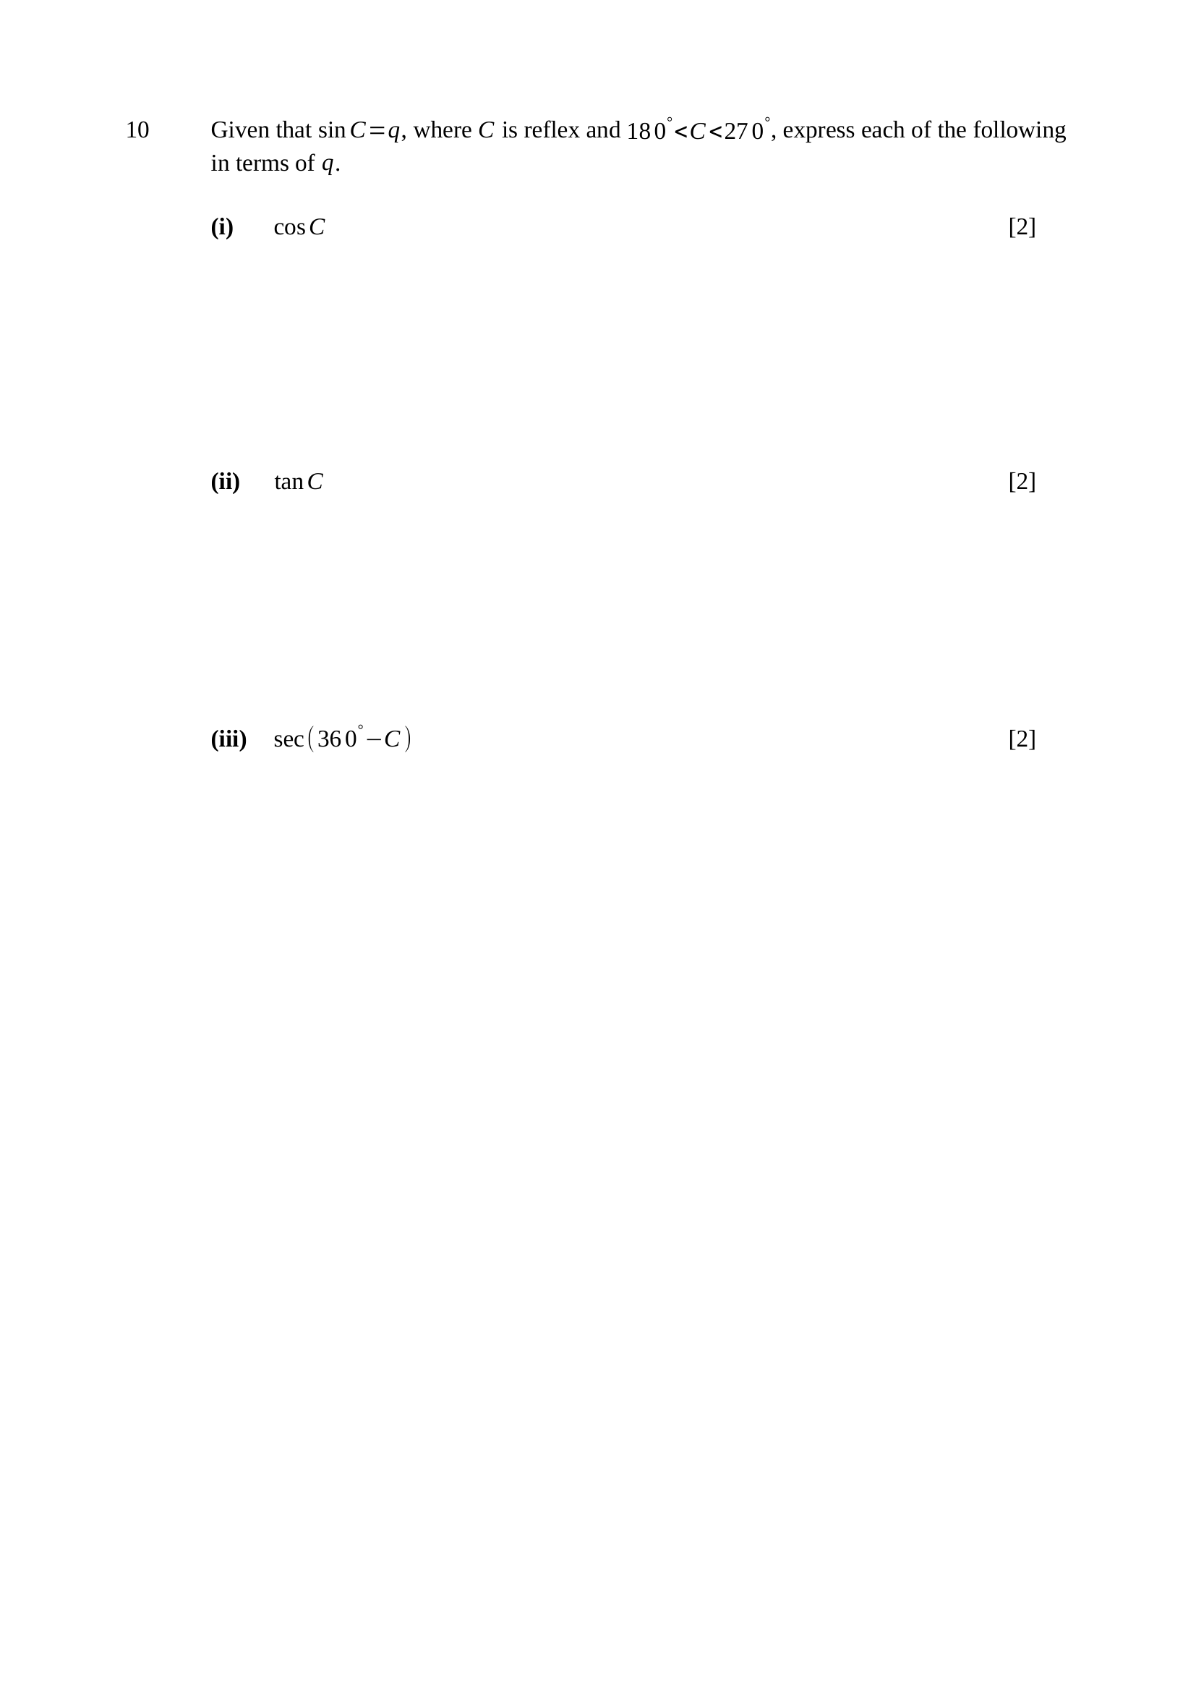
${180}^{∘}<C<{270}^{∘}$, so $C$ is in quadrant 3
in quadrant 3 both sine and cosine are negative
$\sin^{2}C+\cos^{2}C=1$
$\cos^{2}C=1−q^{2}$
$∴cosC=−\sqrt{1−q^{2}}$
Key concept: the quadrant fixes the SIGN; the identity fixes only the size.
M1 – uses $\sin^{2}C+\cos^{2}C=1$
A1 – $cosC=−\sqrt{1−q^{2}}$, negative sign justified by quadrant 3
Note – $q$ is itself negative here, since $sinC<0$ in quadrant 3.
$tanC=\frac{sinC}{cosC}$
$tanC=\frac{q}{−\sqrt{1−q^{2}}}$
$∴tanC=−\frac{q}{\sqrt{1−q^{2}}}$
Key concept: build $tan$ from the two ratios already found — no new triangle.
M1 – $tanC=\frac{sinC}{cosC}$ with both substituted
A1 – $−\frac{q}{\sqrt{1−q^{2}}}$
Note – this is POSITIVE, because $q<0$ — tangent is positive in quadrant 3, a useful check.
$cos\left({360}^{∘} − C\right)=cosC$
$sec\left({360}^{∘} − C\right)=\frac{1}{cosC}$
$sec\left({360}^{∘} − C\right)=\frac{1}{−\sqrt{1−q^{2}}}$
$∴sec\left({360}^{∘} − C\right)=−\frac{1}{\sqrt{1−q^{2}}}$
Key concept: ${360}^{∘}−C$ is a quadrant-4 angle, where cosine keeps its sign — so the value is simply $cosC$.
M1 – $cos\left({360}^{∘} − C\right)=cosC$
A1 – $−\frac{1}{\sqrt{1−q^{2}}}$
Trap – writing $sec\left({360}^{∘} − C\right)=secC$ and then leaving it there — the answer must be in terms of $q$.

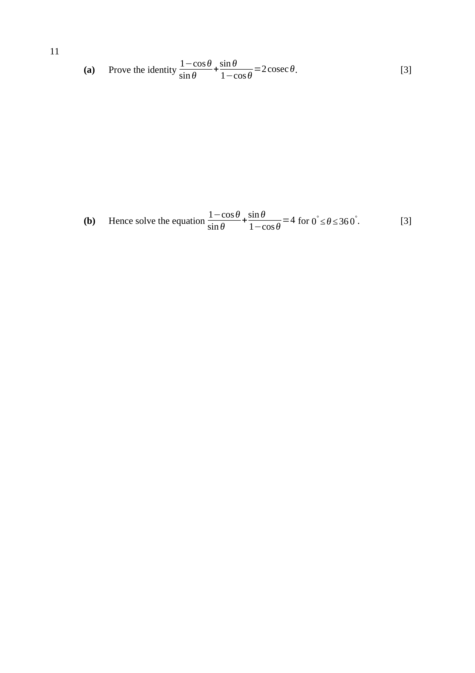
$\text{LHS}=\frac{\left(1−cosθ)^{2}+\sin^{2}θ\right.}{sinθ(1−cosθ)}$
using $\cos^{2}θ+\sin^{2}θ=1$:
$\text{LHS}=\frac{2−2cosθ}{sinθ(1−cosθ)}=\frac{2(1−cosθ)}{sinθ(1−cosθ)}$
$\text{LHS}=\frac{2}{sinθ}=2cosecθ=\text{RHS}$ (proved)
Key concept: work on ONE side only, and let $\sin^{2}θ+\cos^{2}θ=1$ collapse the numerator.
M1 – single fraction over $sinθ(1−cosθ)$
M1 – applies $\cos^{2}θ+\sin^{2}θ=1$ to reach $2−2cosθ$
A1 – cancels $\left(1 − cosθ\right)$ and concludes $2cosecθ$
Trap – cross-multiplying both sides is not a proof — it assumes the result.
by part (a): $2cosecθ=4$
$cosecθ=2$
$sinθ=\frac{1}{2}$
$\text{basic angle}={30}^{∘}$; sine is positive in quadrants 1 and 2
$θ={30}^{∘}$ or $θ={180}^{∘}−{30}^{∘}$
$∴θ={30}^{∘}$ or $θ={150}^{∘}$
Key concept: HENCE — use the identity, do not restart from the fraction.
M1 – $cosecθ=2$, hence $sinθ=\frac{1}{2}$
A1 – $θ={30}^{∘}$
A1 – $θ={150}^{∘}$
Note – $θ=0^{∘}$ and $θ={180}^{∘}$ are excluded anyway — the original expression is undefined there.

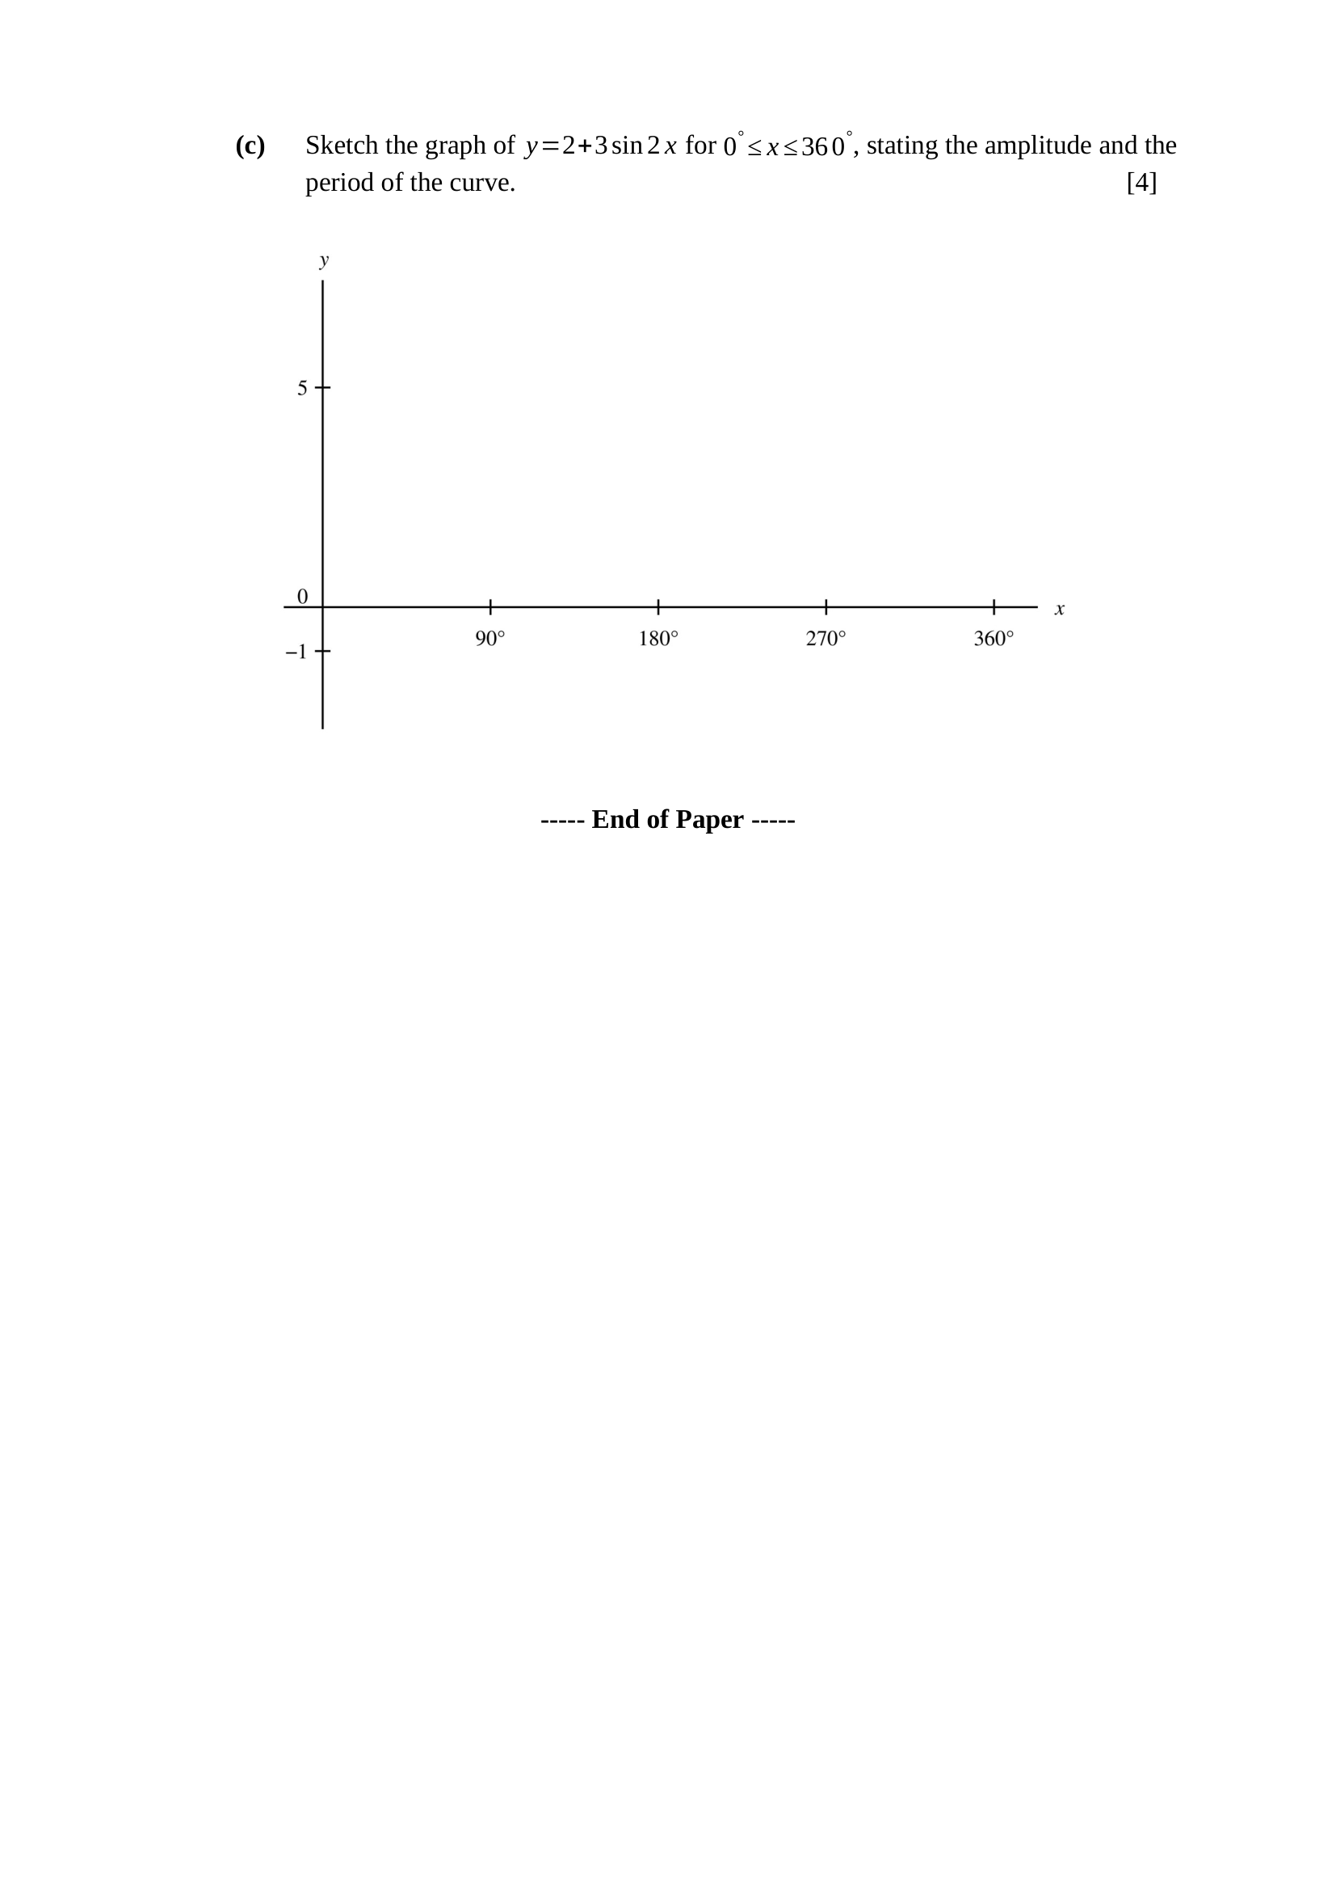
$y=2+3sin2x$
$\text{amplitude}=3$
$\text{period}=\frac{{360}^{∘}}{2}={180}^{∘}$
$\text{maximum}=2+3=5$
$\text{minimum}=2−3=−1$
the curve starts at $\left(0 , 2\right)$, rising
two complete cycles on $0^{∘}≤x≤{360}^{∘}$
maxima at $x={45}^{∘}$ and $x={225}^{∘}$
minima at $x={135}^{∘}$ and $x={315}^{∘}$
Key concept: $sin2x$ halves the period, and the $+2$ lifts the whole curve — the amplitude is unchanged.
B1 – amplitude $3$
B1 – period ${180}^{∘}$
B1 – two complete cycles drawn, starting and ending at $y=2$
B1 – maximum $5$ and minimum $−1$ correctly placed
Trap – drawing one cycle — the period is ${180}^{∘}$, so ${360}^{∘}$ holds exactly two.

